Course DT228 Year 1

Computer Architecture and Technology

ADDITIONAL NOTES FOR THE MULTIPLE CHOICE LAB TEST

(Scheduled for Monday 2nd March in your ‘one-hour lab time’)

The answers to all 50 questions are amongst the text of these notes. This .doc file will be available on Webcourses until midday, Monday 2nd March, giving you a chance to read over them ahead of the test – which will be activated from 2.00 – 3.00pm in the Assessments section of the Webcourses page. Note: this is not an open-book assessment, and you will be expected to complete the test in-lab where you must be sure to sign an attendance log.

SYSTEMS OVERVIEW
Until the early 1980's computer systems were large, expensive and required many expert staff to maintain, operate and program them. The users of such systems were generally restricted to staff within large organisations that could afford the high purchase and operating costs. The advent of high-powered microcomputers has changed this, providing systems which are not only sufficiently powerful to be used throughout commerce and industry but cheap enough to be used in many every-day appliances, e.g. cars, video recorders and so on.

A computer system can be considered as a 'black box' into which information is fed for processing and then results are produced. The information input can range from text (a wordprocessor) or numerical data (a spreadsheet), entered via a keyboard, to diagrams (a CAD design system) entered via a mouse or a digitising tablet. Similarly, information output may be text, numbers or diagrams and pictures presented on a display screen or printer. To communicate with the system, end-users employ terms which are common to their everyday working environment, e.g. accountants use columns of numbers and artists use pictures.

At a superficial level a computer system can be considered as consisting of three components, namely hardware, software and data.

Hardware
The term hardware embraces the physical components of the system:
- The box which contains the printed circuit boards, power supply, etc.
- The display screen and keyboard for user interaction.
- The peripheral devices such as disks and printers.

The internal electronic circuits of modern computers are made up from a number of integrated circuit chips and other components. An integrated circuit chip is a small packaged device a few centimetres square which contains complex electronic circuits. The heart of the modern microcomputer is the microprocessor which is an integrated circuit chip containing the central processing unit (the basic control and processing circuits) of a small computer system. A complete microcomputer system contains a microprocessor plus memory, input/output devices, power supplies, etc.

Software
Software comprises the programs that tell the hardware what to do. A program is a sequence of instructions stored in the memory of the computer system. The central processing unit fetches an instruction, decodes it and then executes the required operation (e.g. to add two numbers). When an instruction has been executed the next instruction is fetched, decoded and executed, etc.

Data
The data is the information to be processed by the computer system. Data may be simple numbers for mathematical calculations, text such as names and addresses or more complex structures such as pictures or drawings. The instructions that make up the program define what data is to be processed, in what form and at what time.

The Central Processing Unit or CPU is the device that does the calculations and the searching and sorting. The CPU is also the part of the computer which carries out the instructions contained in computer programs or software.
The Central Processing unit is made up of different parts:-
a part to perform calculations and comparisons - the Arithmetic and Logic Unit;
a part to control the rest of the computer hardware - the Control Unit;
and
a part to act as temporary storage within the processor - registers.

REPRESENTING INFORMATION
The easiest way to understand bits is to compare them to something you know: digits. A digit is a single place that can hold numerical values between 0 and 9. Digits are normally combined together in groups to create larger numbers. For example, 6,357 has four digits. It is understood that in the number 6,357, the 7 is filling the "1s place," while the 5 is filling the 10s place, the 3 is filling the 100s place and the 6 is filling the 1,000s place. So you could express things this way if you wanted to be explicit:
(6 * 1000) + (3 * 100) + (5 * 10) + (7 * 1) = 6000 + 300 + 50 + 7 = 6357
Another way to express it would be to use powers of 10. Assuming that we are going to represent the concept of "raised to the power of" with the "^" symbol (so "10 squared" is written as "10^2"), another way to express it is like this:
(6 * 10^3) + (3 * 10^2) + (5 * 10^1) + (7 * 10^0) = 6000 + 300 + 50 + 7 = 6357
What you can see from this expression is that each digit is a placeholder for the next higher power of 10, starting in the first digit with 10 raised to the power of zero.

Our base-10 number system likely grew up because we have 10 fingers, but if we happened to evolve to have eight fingers instead, we would probably have a base-8 number system. You can have base-anything number systems. In fact, there are lots of good reasons to use different bases in different situations.

Computers happen to operate using the base-2 number system, also known as the binary number system (just like the base-10 number system is known as the decimal number system). Bytes are frequently used to hold individual characters in a text document. In the ASCII character set, each binary value between 0 and 127 is given a specific character. Most computers extend the ASCII character set to use the full range of 256 characters available in a byte. The upper 128 characters handle special things like accented characters from common foreign languages.

Computers store text documents, both on disk and in memory, using these codes. For example, if you use Notepad in Windows 95/98 to create a text file containing the words, "Four score and seven years ago," Notepad would use 1 byte of memory per character (including 1 byte for each space character between the words - ASCII character 32). When Notepad stores the sentence in a file on disk, the file will also contain 1 byte per character and per space. If you use the explorer and look at the size of the file you will find that the file has a size of the file on disk in bytes: 1 byte for each character.

On the ASCII table a one-to-one correspondence between each character and the ASCII code is used. For example, 32 for a space - 32 is the ASCII code for a space. We could expand these decimal numbers out to binary numbers (so 32 = 00100000) if we wanted to be technically correct -- that is how the computer really deals with things.

The first 32 values (0 - 31) are codes for things like carriage return and line feed. The space character is the 33rd value, followed by punctuation, digits, uppercase characters and lowercase characters.

BINARY OCTAL AND HEX
Computer systems internally represent all information, data and instructions, in binary form, with conversion between binary and human readable forms for input and output. When working in machine code or assembly language it is sometimes necessary to use binary or some similar number system.

binary digit is called a bit. Usually expressed as 0 and 1 the two numbers of the binary numbering system.
A series of eight bits strung together makes a byte, much as 12 makes a dozen. With 8 bits, or 8 binary digits, there exist 2^8=256 possible combinations
Uses numbers 0, 1 - that's 2 numbers. Hence base 2. Binary numbering is the number system that is used by computers.

A bit is the smallest unit of information a computer can use. A 16 bit computer would process a series of 16 bits,such as 0100111101011000 in one go, repeating the process thousands or millions of times per second.

Reading a series of bits is very difficult and to make this process easier they are often displayed in groups of 4 bits 0100 1111 0101 1000. This grouping is quite interesting in that a group of 4 bits can be replaced by a single hexadecimal digit
Two groups of 4 bits, i.e. 8 bits ( a byte) can be replaced by 2 hexadecimal digits,
and 4 hexadecimal digits are required to replace all 16 bits.

Octal
There are other ways to “count ” besides the decimal and binary systems. One example is the octal numbering system (base 8).

The Octal numbering system uses the first 8 numerals starting from 0. The first 20 numbers in the octal system are:
0, 1, 2, 3, 4, 5, 6, 7, 10, 11, 12, 13, 14, 15, 16, 17, 20, 21, 22, 23

Because there are 8 numerals and 8 patterns that can be formed by 3 bits, a single octal number may be used to represent a group of 3 bits.

Hexadecimal
Binary numbers tend to be very long and hence it is easy to make mistakes when dealing with such data. In such situations the hexadecimal (base 16) number system is commonly used (it is very easy to convert between binary and hexadecimal). The hex system uses 16 numerals, starting with zero. The standard decimal system only provides 10 different symbols. So, the letters A-F are used to fill out a set of 16 different numerals. We can use hex to represent a grouping of 4 bits.

Hexadecimal numbers are often displayed in groups of 2, to make them easier to read. E.g.
10 AF 3C 9F

A single hexadecimal number requires 4 units of binary numbers. This makes it reasonably easy to convert between these two numbering systems.

Conversions are possible between different numbering systems:
1 - Binary to Decimal and vice versa
2 - Binary to Octal and vice versa
3 - Binary to Hex and vice versa
4 - Octal to Decimal and vice versa
5 - Hex to Decimal and vice versa
6 - Octal to Hex and vice versa

MEMORY
When we load software from a floppy disk, hard disk or CD-ROM, it must be stored somewhere inside the computer. The main storage space for programs inside the computer is called memory (or main store). There are two types of computer memory inside the computer, RAM and ROM.

RAM
Random Access Memory is really the main store and is the place where the programs and software we load gets stored. When the Central Processing Unit runs a program, it fetches the program instructions from RAM and carries them out. If the Central Processing Unit needs to store the results of calculations it can store them in RAM.

Random Access Memory can have instructions read from it by the CPU and also it can have numbers or other computer data written to it by the CPU.
When we switch a computer off, whatever is stored in RAM gets erased.

ROM
Read Only Memory: the CPU can only fetch or read instructions from Read Only Memory (or ROM). ROM comes with instructions permanently stored inside and these instructions cannot be over-written by the computer's CPU. ROM memory is used for storing special sets of instructions which the computer needs when it starts up. When we switch the computer off, the contents of ROM do not become erased but remain stored permanently.

Measuring Computer Memory
We can think of memory as a series of little boxes (called memory locations), each of which can store a piece of computer data (the data might be a number, a letter or an instruction). It is number of boxes or locations that a computer's memory has, that gives us a measure of the size of its memory.

We measure computer memory in units of thousands of locations and in units of millions of locations.
One thousand memory locations (actually 1024) is known as a Kilobyte (Kb) of computer memory.
One million memory locations (actually 1,024,000) is known as a Megabyte (Mb) of computer memory.

“Kilo” or “Mega” have slightly different values when used with bits per second or with bytes.

When Referring to Bytes (as in computer memory)
Kilobyte (KB) 2¹⁰ = 1,024 bytes
Megabyte (MB) 2²⁰ = 1,048,576 bytes
Gigabyte (GB) 2³⁰ = 1,073,741,824 bytes
Terabyte (TB) 2⁴⁰ = 1,099,511,627,776 bytes

When Referring to Bits Per Second (as in transmission rates)
Kilobit per second (Kbps) = 1000 bps (thousand)
Megabit per second (Mbps) = 1,000,000 bps (million)
Gigabit per second (Gbps) = 1,000,000,000 bps (billion)
Terabit per second (Tbps) = 1,000,000,000,000 bps (trillion)

BUS TYPES
In computer architecture, a bus is a subsystem that transfers data between computer components inside a computer or between computers. Early computer buses were literally parallel electrical buses with multiple connections, but the term is now used for any physical arrangement that provides the same logical functionality as a parallel electrical bus. Modern computer buses can use both parallel and bit-serial connections, and can be wired in either a multidrop (electrical parallel) or daisy chain topology, or connected by switched hubs, as in the case of the Universal serial Bus – USB.

The chipset dictates what sort of buses the system can support; in fact, Intel calls its chipsets "PCIsets" and "AGPsets". Most modern PCs support the ISA and PCI buses, but older chipsets (on 486 class machines) support the VESA Local Bus (VLB) instead of PCI. There are even some 486 PCs that support all three buses on the same motherboard. The newest PCs also add AGP for video.

There are various buses in a PC - expansion bus, expansion slots, slots, I/O bus, I/O system, or channel bus.

Subsystems in a PC communicate to each other via buses (basically, a set of wires). Buses follow a particular set of standard rules to allow compatibility with the numerous subsystems. Every expansion card plugged into a computer's expansion slot needs to communicate with the CPU. To make this easier, there is a communication path that runs from the CPU to the expansion slots so the CPU and the expansion cards can keep in touch. This is the bus. The speed at which the bus can carry data is a key factor in a computer's overall performance, and this speed has been increasing rapidly recently.
Each bus in a PC has a speed (measured in megahertz) and a data transfer rate. In 1996 and 1997, the PC industry standardized around the 66 MHz Front Side Bus. A 100 MHz Front Side Bus came in 1998, then 133 MHz in 2000. The Pentium 4 introduced a 400 MHz Front Side Bus in late 2000.

ISA: The original bus type in the first IBM PCs was ISA. It was narrow (16 bit) and slow and ISA expansion slots are not often found on motherboards today.

The EISA (Extended Industry Standard Architecture) bus is a 32-bit bus introduced in 1989. It was produced to solve the problems of the ISA bus while maintaining compatibility with ISA plug-in cards (an old ISA card could be plugged into an EISA slot.)

Micro Channel (a 32 bit proprietary bus designed by IBM, which did not become very popular) and EISA had higher performance and advanced features over ISA. Since then, however, both have been replaced by PCI and PCI-X.

High-speed memory local buses were first introduced in 1985. The slow data transfer rate of the ISA bus required processors to go into wait states (i.e. it would twiddle its thumbs while waiting for data to arrive from memory chips) when requesting reads or writes to or from main memory. The memory local bus helped to solve this problem. All PCs use a memory local bus today.

PCI enhances performance for I/O-intensive operations such as storage and communication devices in servers, graphics, and video in desktops and notebooks. PCI offers multiple expansion slots. PCI is an industry standard. A PCI system could have peripherals (disk controller, LAN controller) on the systemboard and/or have open slots or connectors so whether the peripheral is on the motherboard or in an expansion slot, it uses the PCI command set to transfer data.

AGP is a special slot for high speed graphics cards; it has a direct line to the CPU.

PCI Express - even faster, a family of slots for ultra-high speed expansion cards.

Universal Serial Bus (USB) allows the addition of a new device to a PC by plugging it into the back of the machine or daisy-chaining it from another device on the bus. The device is immediately available for use (no rebooting required) and often does not need a device driver to be installed (depending on the operating system being used.

A big advantage of USB devices, apart from their much greater speed, is that USB devices configure themselves automatically: gone are the days when you had to fiddle with IRQ settings, DMA channels, and I/O addresses to make a gadget work. Another advantage of USB is that it is a standard port and can support just about any type of device, including keyboards, mice, serial peripherals (e.g. modems), printers, audio input/output, joysticks, digital cameras, scanners, external hard disks and CD burners. The other advantage is that you can mix and match devices as much as you like. In the old days, if you had a parallel port scanner and a printer, they had to share the single printer port (and neither of them would work properly for long.) If you have several USB devices, it is best to use a USB hub. This is a little box that splits a single USB port into 4 or more ports.

FireWire - a.k.a. IEEE 1394 provides a standardized high-speed serial bus to link computer and consumer peripherals to PCs through a common, high-speed serial port. It can connect 1394-compatible peripherals like disks, CD-ROMs, printers, and scanners, as well as digital consumer electronic products such as digital cameras, camcorders, stereo systems, set top boxes, HDTVs, DVD players, and speakers. IEEE 1394b - the next generation Firewire - supports 800 Mbps to 3.2 Gbps. Over plastic fiber-optic cable or Category 5 copper wire, 1394b networks can span 100 meters. Over glass fiber, 1394b can transmit over several kilometers. A 1394 cable consists of six wires. Four of the six shielded wires are used for data and control signals; the other two carry power.
Firewire seems to have lost out to USB, but is still popular in particular situations, such as linking video cameras to computers.

A typical desktop PC today has two main buses:
The first one, known as the system bus or local bus, connects the microprocessor (central processing unit) and the system memory. This is the fastest bus in the system.

The second one is a slower bus for communicating with things like hard disks and sound cards. One very common bus of this type is known as the PCI bus. These slower buses connect to the system bus through a bridge, which is a part of the computer's chipset and acts as a traffic cop, integrating the data from the other buses to the system bus.

BOOLEAN ALGEBRA
Every digital circuit has inputs and outputs. Then, purpose of the digital circuit can be thought of as "matching" an output to a certain input (or a sequence of inputs). For example, a digital circuit can be designed to control the movement of an elevator. The inputs are the floor you are on and the floor you want to go to. The output is the motor being turned on in the right direction for the correct period of time. To design this and more complicated digital circuits, we use a field of mathematics called boolean algebra.

Like school algebra, boolean algebra also deals with variables and operations performed on them. In boolean algebra, the variables usually represent the logic state of some part of the circuit (usually inputs). The output is then represented as an expression containing these variables and operations to be performed on them. And like an algebraic expression, boolean expressions can be simplified. The usefulness of this is evident if you imagine a digital circuit containing a million transistors being simplified into a circuit of only 10 transistors.

To begin our study of boolean algebra, consider some arbitary input variables A and B and an output variable Y. We shall perform the basic operations AND, OR and NOT on them to demonstrate how boolean algebra is used.
AND(.): Y is equal to A AND B: Y = A.B
OR(+): Y is equal to A OR B: Y = A+B
NOT: Y is equal to NOT A:
A typical boolean expression is Y = (A+B').(A'.B)

A Boolean algebra is a set with two binary operations, and , that are commutative, associative and each distributes over the other, plus a unary operation . Also required are identity elements and U for the binary operations that satisfy , , and for all elements A in the set.

An important principle in the boolean algebra system is that of duality. Any valid expression you can create using the postulates and theorems of boolean algebra remains valid if you interchange the operators and constants appearing in the expression. Specifically, if you exchange the and + operators and swap the 0 and 1 values in an expression, you will wind up with an expression that obeys all the rules of boolean algebra. This does not mean the dual expression computes the same values, it only means that both expressions are legal in the boolean algebra system. Therefore, this is an easy way to generate a second theorem for any fact you prove in the boolean algebra system.

will use these theorems to show that two boolean equations are identical. This is an important operation when attempting to produce canonical representations of a boolean expression or when simplifying a boolean expression.

A boolean expression is a sequence of zeros, ones, and literals separated by boolean operators. A literal is a primed (negated) or unprimed variable name. Another way to represent a boolean function is via a truth table. Digital logic functions can operate on between one and many signals and have either one or many results. A standard way to represent these inputs and outputs is using a Truth Table to list the inputs and outputs of a digital logic function.

You can transform one boolean expression into an equivalent expression by applying the postulates the theorems of boolean algebra. This is important if you want to convert a given expression to a canonical form (a standardized form) or if you want to minimize the number of literals (primed or unprimed variables) or terms in an expression. Minimizing terms and expressions can be important because electrical circuits often consist of individual components that implement each term or literal for a given expression. Minimizing the expression allows the designer to use fewer electrical components and, therefore, can reduce the cost of the system. Unfortunately, there are no fixed rules you can apply to optimize a given expression. Much like constructing mathematical proofs, an individual's ability to easily do these transformations is usually a function of experience.

The addition and multiplication operations of Boolean Algebra ARE NOT mathematical addition and multiplication. These two operations use the signs (+) and (*) in order to facilitate understanding Boolean Algebra, but never forget that they are not the mathematical addition and multiplication. The rules governing Boolean addition and multiplication follow next.
The sign "=" used in Boolean Algebra IS NOT the mathematical "=". In Boolean Algebra "=" means "may be substituted with/for" not "equal to".

LOGIC GATES
Boolean functions may be practically implemented by using electronic gates. The following points are important to understand.
Electronic gates require a power supply.
Gate INPUTS are driven by voltages having two nominal values, e.g. 0V and 5V representing logic 0 and logic 1 respectively.

The OUTPUT of a gate provides two nominal values of voltage only, e.g. 0V and 5V representing logic 0 and logic 1 respectively. In general, there is only one output to a logic gate except in some special cases.

There is always a time delay between an input being applied and the output responding.

To implement a logic gate in hardware, you use a transistor
Transistors are all enclosed in an “IC”, or integrated circuit
The Intel Pentium IV processors had 55 million transistors, for example.

Logic gates are small (several micron) structures which take one or more bits as input, and produce another bit as output

Different logic gates use different techniques to calculate their output. The most common logic gates used perform the following logic functions:
  - AND: output is 1 if all inputs are 1
  - OR: output is 0 if all inputs are 0
  - XOR: output is the sum (mod 2) of all inputs
  - NOT: output is the opposite of the single input
  - NAND: output is 0 if all inputs are 1
  - NOR: output is 1 if all inputs are 0
  - XNOR: output is the inverse of the XOR gate
- By linking the output of one gate to the inputs of other gates, we can carry out more powerful calculations

There have been several different types of logic circuit over the years all of there names are based on the way the various components are interconnected internally.
DCTL | Direct-Coupled Transistor Logic
RTL | Resistor-Transistor Logic
RCTL | Resistor-Capacitor-Transistor Logic
DTL | Diode-Transistor Logic
ECL | Emitter-Coupled Logic
TTL | Transistor-Transistor Logic
MOS | Metal-Oxide Semiconductor Logic
CMOS | Complementary Metal-Oxide Semiconductor Logic

Out of all these logic types TTL, MOS, and CMOS are the ones used today.

Most logic families share a common characteristic: their inputs require a certain amount of current in order to operate correctly. CMOS gates work a bit differently, but still represent a capacitance that must be charged or discharged when the input changes state. The current required to drive any input must come from the output supplying the logic signal. Therefore, we need to know how much current an input requires, and how much current an output can reliably supply, in order to determine how many inputs may be connected to a single output.
However, making such calculations can be tedious, and can bog down logic circuit design. Therefore, we use a different technique. Rather than working constantly with actual currents, we determine the amount of current required to drive one standard input, and designate that as a standard load on any output. Now we can define the number of standard loads a given output can drive, and identify it that way. Unfortunately, some inputs for specialized circuits require more than the usual input current, and some gates, known as buffers, are deliberately designed to be able to drive more inputs than usual. For an easy way to define input current requirements and output drive capabilities, we define two new terms:
Fan-in
The number of standard loads drawn by an input to ensure reliable operation. Most inputs have a fan-in of 1.

Fan-out
The number of standard loads that can be reliably driven by an output, without causing the output voltage to shift out of its legal range of values.
Remember, fan-in and fan-out apply directly only within a given logic family. If for any reason you need to interface between two different logic families, be careful to note and meet the drive requirements and limitations of both families, within the interface circuitry.

Flip Flops and Latches
A flip-flop holds a single bit of memory and the bit “flip-flops” between the two NAND gates. In reality, flip-flops are a bit more complicated. They have 5 (or so) logic gates (transistors) per flip-flop… Consider a 1 Gb memory chip: 1 Gb = 8,589,934,592 bits of memory. That’s about 43 million transistors! In reality, those transistors are split into 9 ICs of about 5 million transistors each.

The NAND and NOR gates are called universal functions since with either one the AND and OR functions and NOT can be generated. Note: a function in sum of products form can be implemented using NAND gates by replacing all AND and OR gates by NAND gates. A function in product of sums form can be implemented using NOR gates by replacing all AND and OR gates by NOR gates.

ASSEMBLER
Assembler languages are ‘machine oriented‘ languages. Programs orient on special hardware properties. They are more comfortable than machine code (e.g. by using symbolic notations).

The language is translated into machinecode language (Interpreter). Each operation code(opcode) owns one symbolic command. Assignments of operand addresses are possible. Labels are used for command addresses.

Assemblers involve a set of concepts that enable code to be written in a language and then used to control the computer's operations. These concepts include the assignment of labels to represent locations in memory (e.g. letters such as X, Y, Z). Fixed names are given to operations such as STORE, LOAD and ADD as well as registers (e.g. R1, R2). Numbers written in decimal are also converted to binary.

Each line in assembly language translates to a single machine code instruction. Assembly languages are machine specific and require an understanding of the structure of the machine in order for that machine to be used to its potential. Assembly language is also very hard to learn.

The Assembly Process
-- a computer understands machine code
-- people (and compilers) write assembly language

assembly ----------------- machine
source --> | assembler | --> code
code -----------------

an assembler is a program - a very deterministic program - it translates each instruction to its machine code.

In the past, there was a one-to-one correspondence between assembly language instructions and machine language instructions. This is no longer the case. Assemblers are now-a-days made more powerful, and can "rework" code.

The Pentium (being based on the 8086) has a one-to-one correspondence between assembly language instructions and machine language instructions.

Assembly
The assembler's job is to
1. assign addresses
2. generate machine code

An assembler will
assign addresses
generate machine code
generate an image of what memory must look like for the program to be executed.

A simple assembler will make 2 complete passes over the data (source code) to complete this task.

Pass 1: create complete Symbol Table
generate machine code for instructions other than branches, jumps, call, etc. (those instructions that rely on an address for their machine code).

Pass 2: complete machine code for instructions that didn't get finished in Pass 1.

The assembler starts at the top of the source code program, and SCANS. It looks for
directives (.data .code .stack .486, etc. )
instructions

IMPORTANT:
There are separate memory spaces for data and instructions. The assembler allocates them IN SEQENTIAL ORDER as it scans through the source code program. The starting addresses are fixed - ANY program will be assembled to have data and instructions that start at the same address.

Generating Machine Code for an Instruction
This is complex due to the large variety of addressing modes combined with the large number of instructions.

Most often, the machine code for an instruction consists of
1.) an 8-bit opcode
(the choice of opcode will depend somewhat on the addressing modes used for the operands)
followed by

2.) one or more bytes describing the addressing modes for the operands.

INPUT DEVICES
Input devices are used to get data into a system. They should be able to do this as accurately and quickly as possible, and with the minimum of human intervention. The most common types of input devices are:
Keyboards

Point and Click devices (including mouse, tracker balls, touch sensitive pads, joysticks, light pens, touch screens, and graphic tablets)

Readers (including magnetic strip readers, barcode readers, optical character readers/recognition, magnetic ink character readers/recognition, and optical mark readers/recognition)

Punched cards and tape (including punched cards and Kimball tags)

Sound capture devices (including voice recognition and microphones)

Terminals (including EPOS and EFTPOS terminals)

Digital imaging devices (including video digitisers, scanners, digital cameras, and web cams)

Tonal devices (including touch tone telephones)

The most common type of keyboard is the QWERTY keyboard (so called because the top line of letters are q, w, e, r, t, and y.

Another type of keyboard is the concept keyboard. They can be specially designed so that people with restricted vision can use them to interface with a computer. Concept keyboards can also be programmed to perform common functions with one keystroke (e.g. a computerised till in a fast food restaurant).

Point and Click devices include mouse, tracker balls, touch sensitive pads, joysticks, light pens, touch screens, and graphic tablets.

The mouse translates movement on the desktop into digital information. This is information is converted into movement of the cursor on the screen. A mouse will also have one, two, or three buttons which can be clicked to help the user to select what functions they wish to use. The tracker ball is essentially an upside down mouse. Instead of moving the mouse on the table top, the ball is rotated. This achieves the same result as using a mouse but takes up far less room.

Joysticks are most commonly used to interact with computer games, although they are also used in other circumstances (e.g. on hospital scanners). Like the tracker ball, the movement of the joystick moves the cursor on the screen. The touch screen is a special type of screen which is sensitive to touch. Selections can be made by touching the screen. These are particularly useful in banks, building societies, and shops, where customers who are not used to using a keyboard can interact with a computer system.

The most common types of reader used include magnetic strip readers, barcode readers, optical character readers/recognition, magnetic ink character readers/recognition, and optical mark readers/recognition).

OUTPUT DEVICES
Output is usually processed data or information. Types of output are:
Text
Graphics
Audio and video

Output devices include monitors, printers and other devices.

Monitors - known as screens or display screens
Output referred to as soft copy.

Features are:
Resolution-pixels
Dot pitch
Refresh rate
Size
Cathode-ray tube or CRTs
Flat-panel – this require less power to operate, is more portable and thinner than CRTs. There are other monitors:
E-books
Data projectors
High-definition television (HDTV)

Printer - translates information that has been processed by the system unit. The output is referred to as ‘hard copy’. Features for printers are resolution, colour capability, speed and memory.

There are:
Ink-jet printers
Laser printers
Personal laser printers
Shared laser printers
Thermal printer
Other printers:
Dot-matrix
Plotters
Photo printers
Portable printers

Audio output - Translates audio information from the computer into sounds that people can understand. Common devices are speakers and headphones.

STORAGE DEVICES
Main memory –
Random Access Memory (RAM) is composed of integrated units
SDRAM--Synchronous Dynamic RAM
DIMMs--Dual Inline Memory Modules

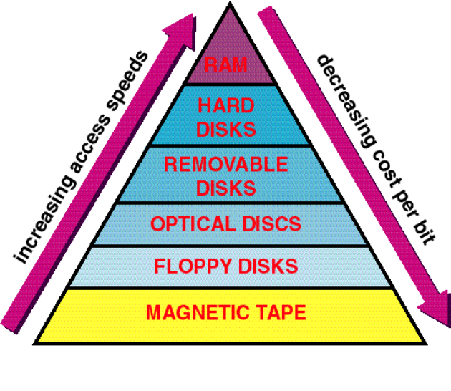
Random access
items are independently addressed
access time is constant

Direct access
items are independently addressed in regions
access time is variable—though not significantly

Sequential access
items are organized in sequence (linearly)
access time is significantly variable

Sequential Access Storage Devices and Media (SASD)
magnetic tape

Direct Access Storage Devices and Media (DASD)
magnetic floppy disks
magnetic hard disks
optical discs

CD ROM
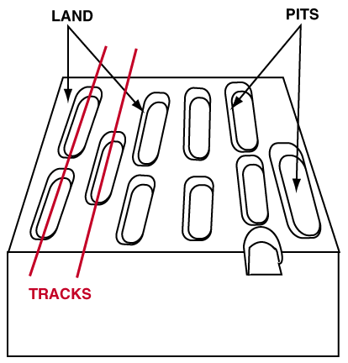
Based on CDDA technology
CLV geometry
density: 16,000 tpi
up to 650 MBytes
nonerasable, nonwriteable storage
discs are mastered, pressed (mass production)
multispeeds drives common

CD –R

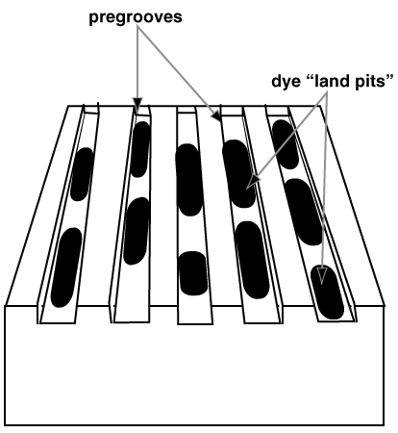
discs are “burnt” one at a time
high intensity laser beam used for recording pregrooved tracks
low intensity beam for reading
attributes similar to CD-ROM

DVD
Digital Versatile Disc
second generation CD-ROM
higher capacity:
higher data density
multiple sides
multiple layers

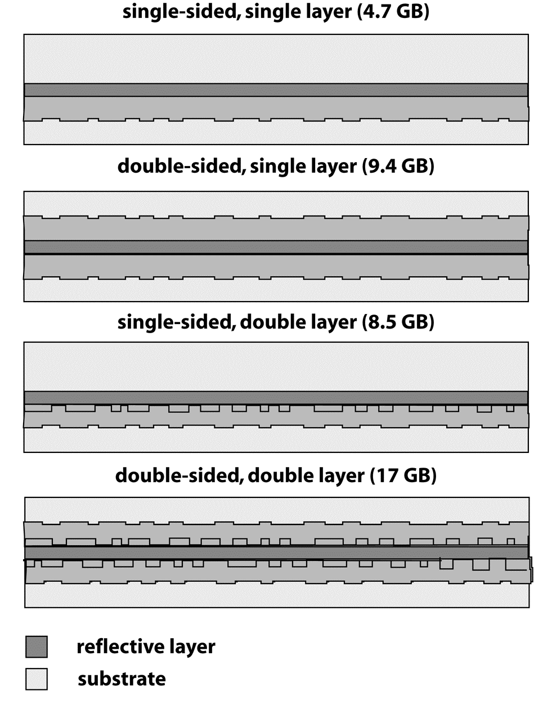

NETWORKS
Computer networks - Communication between applications on different computers.
A network designer must understand:
application needs/demands
Traffic data rate
Traffic pattern (bursty or constant bit rate)
Traffic target (multipoint or single destination, mobile or fixed)
Delay sensitivity
Loss sensitivity

Four steps:
Communicating across a link
Connecting together multiple links (internetworking)
Finding and routing data to nodes on internetwork
Matching application requirements

Creating a link between nodes. Link: path followed by bits - wired or wireless. Broadcast or point-to-point (or both). Node: any device connected to a link

Packet transmission modes:
- Unicast
  - Transmission to single specific receiver
- Broadcast
  - Transmission to all network nodes
- Multicast
  - Transmission to specific subset of nodes
- Anycast
  - Transmission to one of a specific subset of nodes

Switched networks –
- Switch: moves bits between links
  - Packet switching
  - Circuit switching

Packet switching - Interleave packets from different sources
- Efficient: resources used on demand
  - Statistical multiplexing
- General
  - Multiple types of applications
- Accommodates ‘bursty’ traffic
  - Addition of queues
Example: the internet

TDM
- Synchronous time division multiplexing

DIAGNOSTICS
Computer diagnostics is a difficult field because Internet's evolution as a composition of independently developed and deployed protocols, technologies, and core applications.
Diversity, highly unpredictable, hard to find “invariants”
Rapid evolution and change, no equilibrium so far
Findings may be out of date
Measurement/diagnosis not high on vendors list of priorities
Resources/skill focus on more interesting an profitable issues
Tools lacking or inadequate
Implementations are flaky & not fully tested with new releases
Distributed systems are very hard
A distributed system is one in which I can't get my work done because a computer I've never heard of has failed. Butler Lampson
Network is deliberately transparent
The bottlenecks can be in any of the following components:
the applications
the OS
the disks, NICs, bus, memory, etc. on sender or receiver
the network switches and routers, and so on
Problems may not be logical
Most problems are operator errors, configurations, bugs
When building distributed systems, we often observe unexpectedly low performance
the reasons for which are usually not obvious
Just when you think you’ve cracked it, in steps security
Firewall, NAT boxes etc.
Block pings, traceroute looks like port scan, diagnostic tool ports are blocked …
ISPs worried about providing access to core, making results public, & privacy issues

Problems might come from –
Host “errors”
TCP buffers, heavy utilization …
Duplex mismatch (Ethernet)
Misconfigured router/switches
Including routing errors, especially for backup paths
Bad equipment, wiring/fiber problem
Congestion

Ping
- to localhost,
- ping to gateway (use route or traceroute to find gateway),
- ping to well known host and to relevant remote host

Traceroute to remote host
Is the route direct, over commercial congested nets

Reverse traceroute from remote host to you or 3rd party

Diagnostic tools
Ntop – network traffic monitoring that shows nework usage, for example
Summarises libpcap (sniffer) information
Internet2 Detective:
Tests connectivity to I2, bandwidth, multicast, IPv6
Can run as Java applet

NLANR Internet Advisor

Ethereal, tcpdump, snoop

Passive tools:
Netflow for characterizing network, spotting abnormalities, e.g.

SNMP based tools

Wireless
Avoid peer-to-peer/ad-hoc connections
Disable connecting to ad-hoc (set infrastructure only)
Disable bridging
How to do it varies by OS (XP, OSX, Linux)
Ad hoc can still interfere if on same channel
Tools to locate an access point (e.g. Yellow-Jacket)

Vendors have management tools to enable APs to detect rogue APs

COMPUTERS IN PRACTICE
Information technology can be used:
  - To help solve crime.
  - In the supermarket.
  - In the music industry.
  - In the TV and video industry.
  - In medicine.
  - In banking.
  - To control traffic.
  - To monitor pollution.
  - In education.

For example, The TV and video industry use ICT:
To produce CGI (Computer Generated Graphics) for use in animations, films, and videos.
To speed up the whole process of producing animations (computers do not need to produce individual film cells for each frame of an animation).
To create special effects.

In education computers are used:
For interactive learning (e.g. using whiteboards, self-marking tests, educational games).
For distance learning (where pupils can access learning programs and/or information from home via the Internet).
For administration (e.g. examination entries, reports, attendance).

The applications of computer systems to their specialty with consideration of limitations due to accuracy, size – a problem which can be solved, etc.

Purchase and installation of a computer system may involve:
- carrying out a feasibility study to determine disadvantage of installing a computer system.
- drawing up a specification of a computer system to suit their requirement from the specification draw up an ITT (Invitation to Tender) which will be sent to prospective vendor processing tenders and shortlisting vendors.
- systems using various criteria, e.g. cost, functionality, usability system.
- installation and acceptance tests training, system management, maintenance, etc.

